WEB RECONNAISSANCE USING THEHARVESTER
Aim
To perform passive information gathering (reconnaissance) for a target domain using theHarvester and observe the publicly discoverable information returned by available sources.
Procedure
- Open a terminal in an authorized lab environment where theHarvester is installed.
- Run theHarvester against a domain you own or have explicit permission to assess. In the screenshots, the example target is www.zoho.com.
- Review the output for discovered IP addresses, autonomous system numbers (ASNs), URLs, subdomains, hosts, emails, and people, where sources provide them.
- Check warning messages. Many integrations require API keys configured in /etc/theHarvester/api-keys.yaml; missing or invalid keys cause those sources to be skipped or return limited results.
- Record the results and limitations, then stop. Do not scan, probe, or attempt access to systems without explicit authorization.
Observations
The screenshots show theHarvester 4.11.1 running with the target www.zoho.com. The output reports 41 IP addresses, 13 ASNs, and 15 interesting URLs. It reports no emails, people, hosts, or LinkedIn links in the displayed results. Several data sources report missing or invalid API keys, so the results are incomplete and should not be treated as an exhaustive inventory.
Result
TheHarvester reconnaissance output was reviewed and summarized. The displayed run returned IP and ASN information and interesting URLs, while several integrations were unavailable due to missing or invalid API credentials. Use this procedure only for domains you are authorized to assess.

Screenshots
Screenshot 1
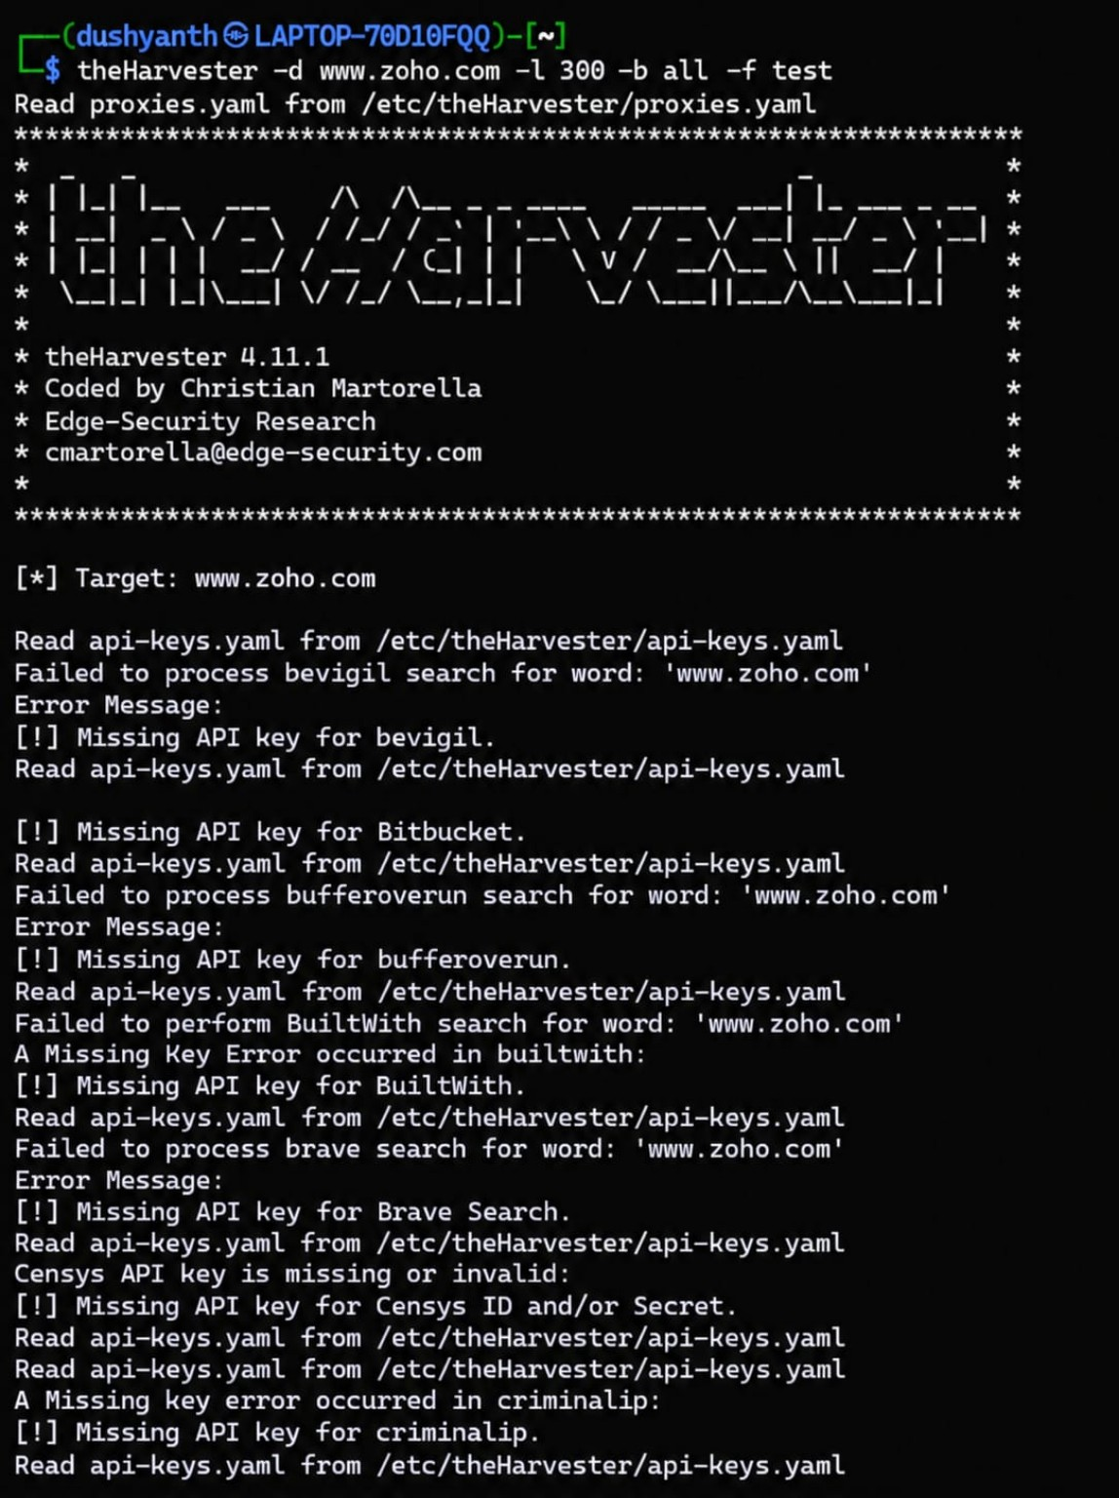
Screenshot 2
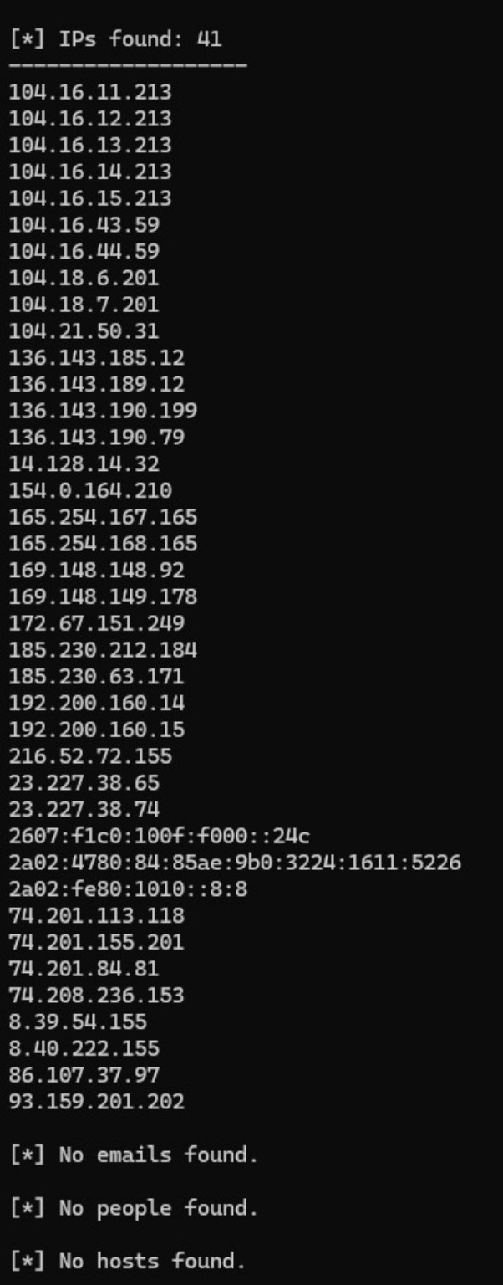
Screenshot 3
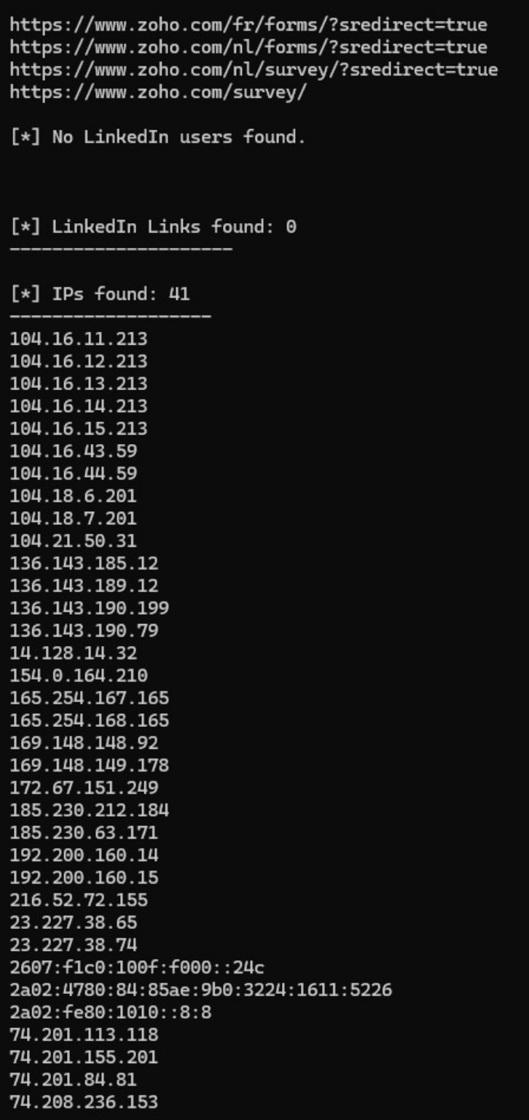
Screenshot 4
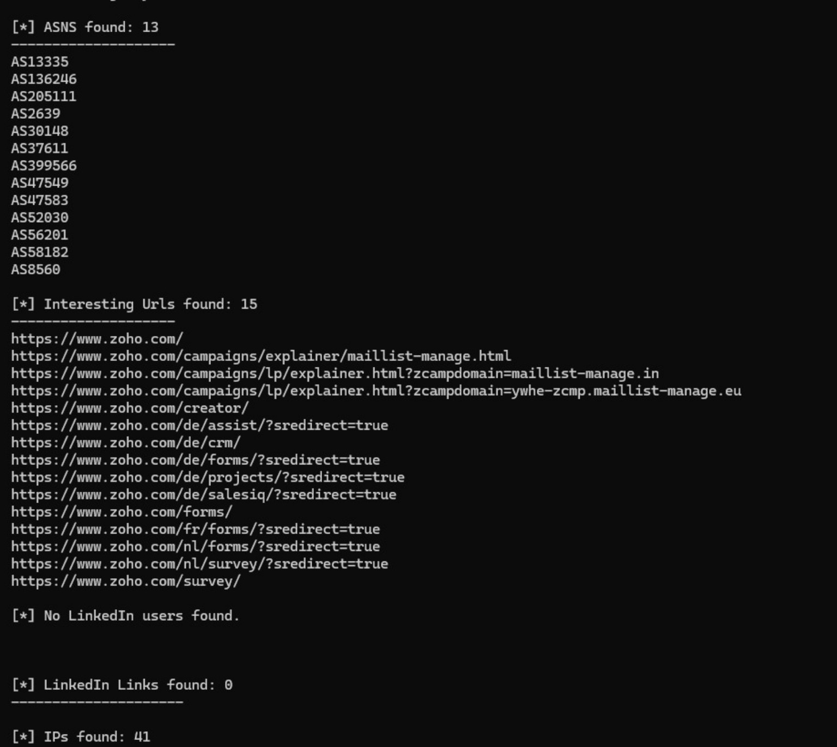
Screenshot 5
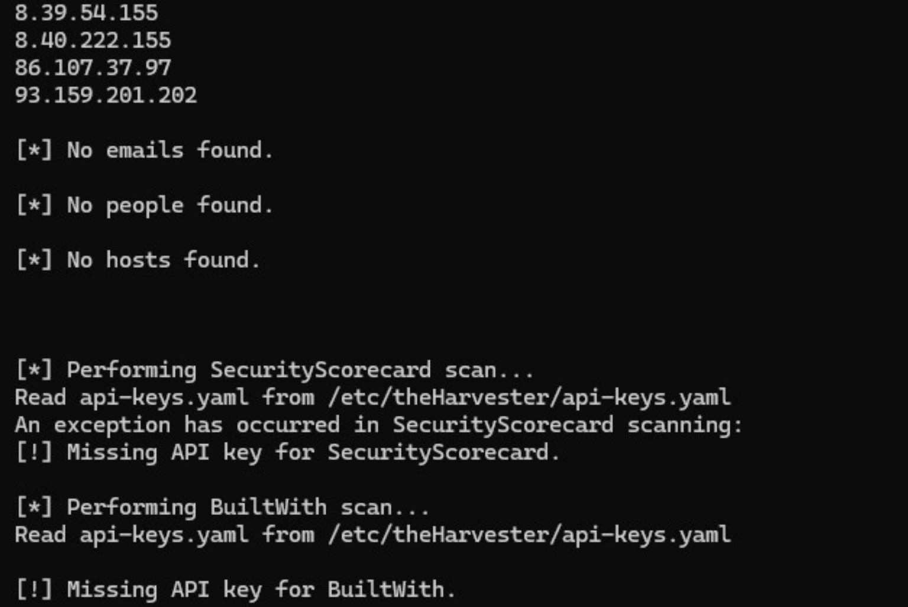
Screenshot 6
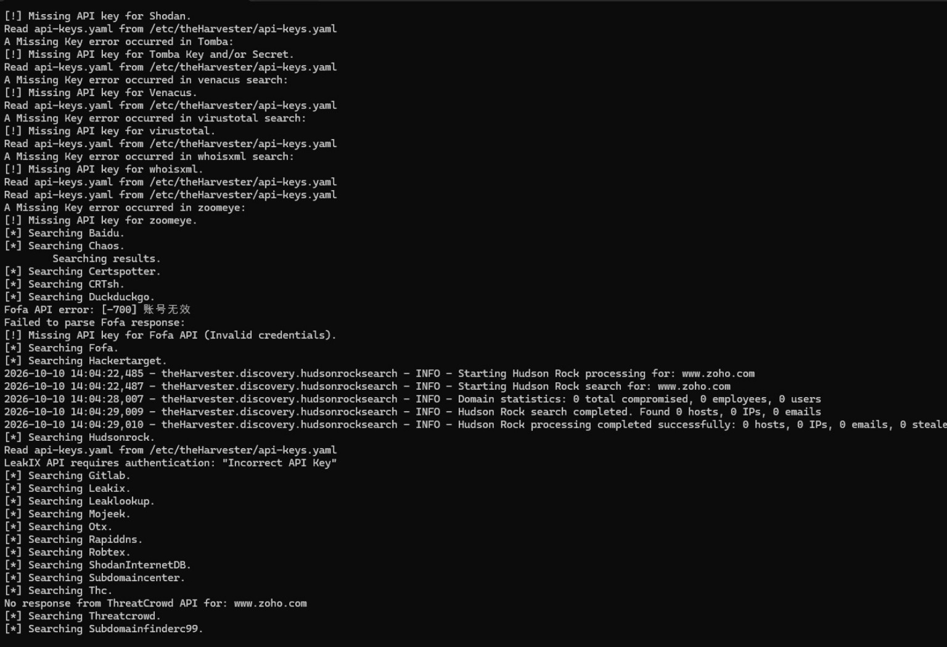
Screenshot 7
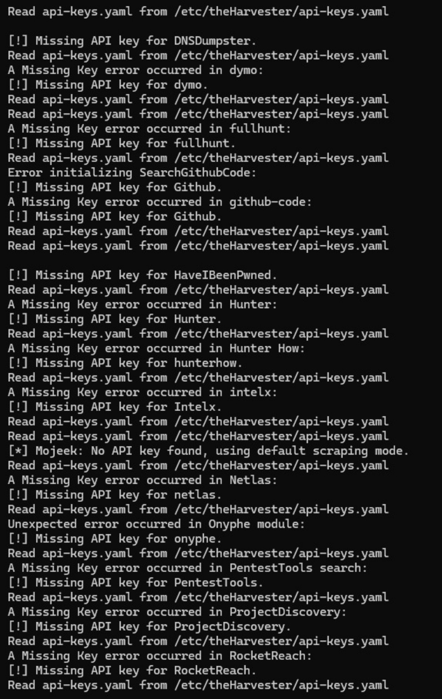
Screenshot 8
